**Technical Test**

Write a program “action-monitor” satisfying these requirements:

1. The program must be written in Java. Using the following libraries/ frameworks/ containers is optional but if used, it will be appreciated.

# Maven 3

# Tomcat

# Spring (core, mvc, integration)

# SL4j + Logback (for logging purposes)

# A lightweight database

# WebSockets - Spring

# ActiveMQ

#EasyMock, Mockito or other

2. The program should monitor the inserts in a database table and notify all the browsers with a session established every time the contents of the table change.

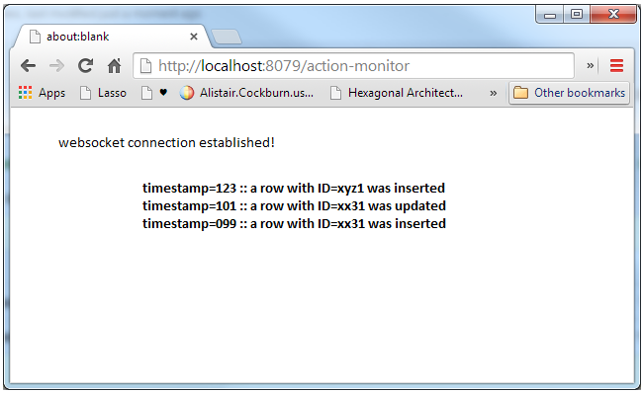

**Stretch goals – to be implemented only if you have time**

3. The program should expose 2 rest endpoints returning:

* OK if the application is running

* Version of the application

4. Please submit your source code along with:

* A README document detailing how to build and deploy the code or other detail you find relevant.

5. Please provide us your code using Git via Githubn and let us know of its location.

**The following points will also affect your score:**

1. We need to be able to easily build and run the program.

2. Make it easier for us to exercise the system (interacting with the database you choose inserting/ updating rows).

3. We will be looking at the code and tests and assessing style, implementation and test coverage.

**Important Note:** Even if you are not able to complete the exercise, if you feel that whatever you achieve will show the way you think and code, submit the code anyway. We also take into consideration the decisions given the time constraints.